AI Assited coding Assignment-12.4
Name:Kanneboyina Meghana
Batch-44
HTNO:2303a52345
Task 1: Bubble Sort for Ranking Exam Scores
Prompt: Add inline comments and explain time complexity for Bubble Sort with early termination.
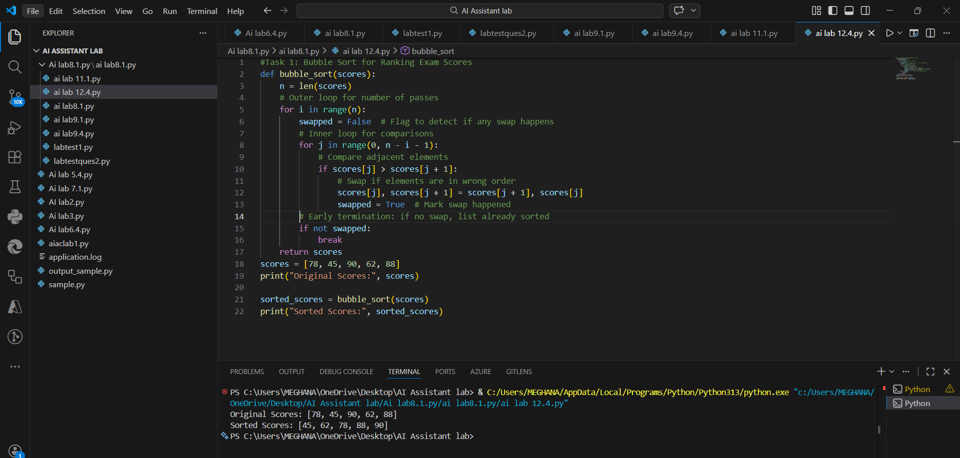
Time Complexity
Case | Complexity
Best Case (Already Sorted) | O(n)
Average Case | O(n²)
Worst Case (Reverse Sorted) | O(n²)
Expalnation:
1.Bubble Sort is easy to understand and implement.
2.It repeatedly compares adjacent elements and swaps them if needed.
3.Early termination reduces unnecessary passes when the list is already sorted.
4.Best case time complexity: O(n) (already sorted).
5.Average and worst case time complexity: O(n²).
6.Not suitable for large datasets.
Task 2: Improving Sorting for Nearly Sorted
Attendance Records
Prompt: Suggest better sorting algorithm for nearly sorted data and implement it.
1.Bubble sort:

2.insertion sort:
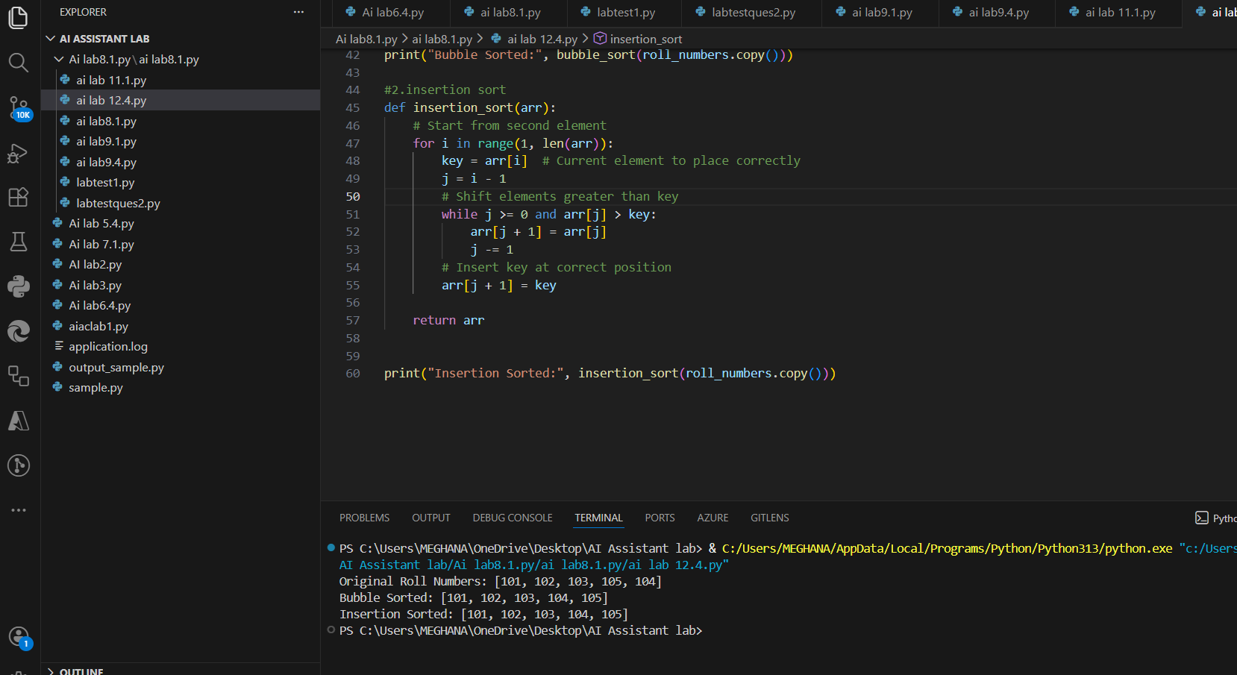

Expalnation:
Why Insertion Sort Performs Better for Nearly Sorted Data
1.Insertion Sort only shifts misplaced elements.
2.It does not repeatedly compare already sorted elements.
3.If only 1–2 elements are misplaced, it fixes them quickly.
4.Best case time complexity is O(n).
5.Bubble Sort still checks many unnecessary comparisons.
Task3: Task 3: Searching Student Records in a
Database
Prompt: “Implement Linear and Binary Search with docstrings, explain when Binary Search is applicable, and compare performance.”
1.linear search(for unsorted):
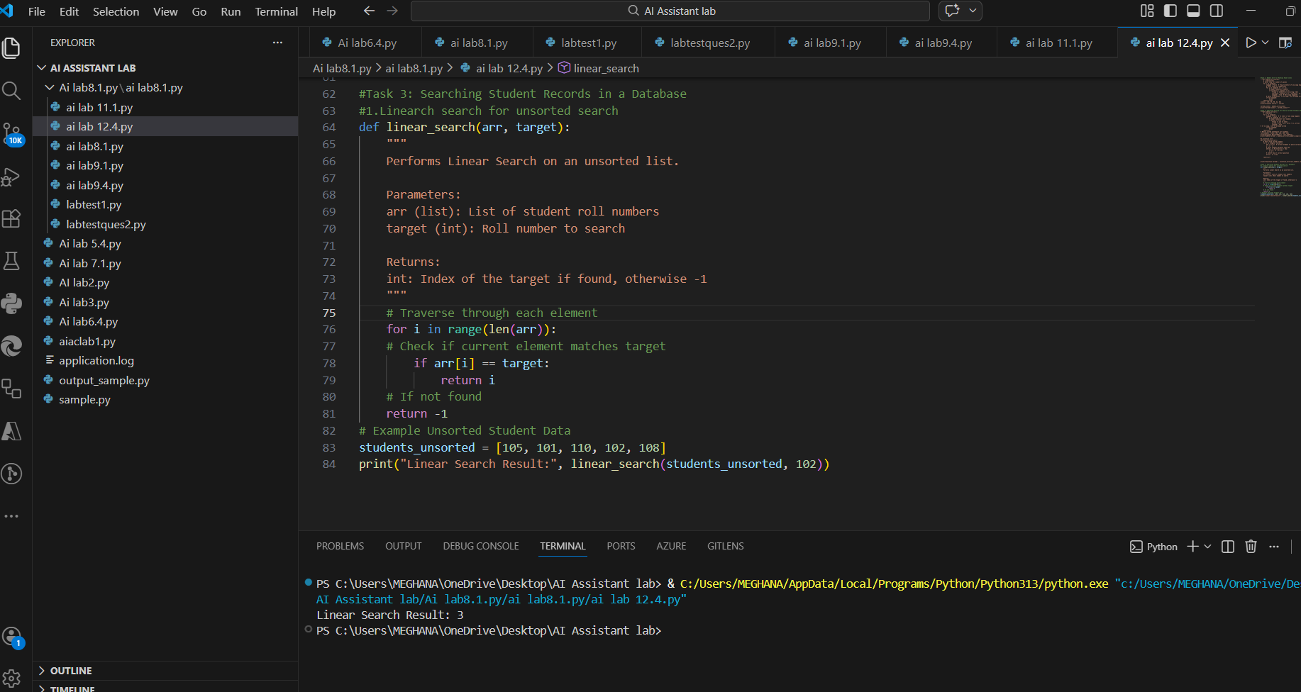
2.binary serach(for sorted):
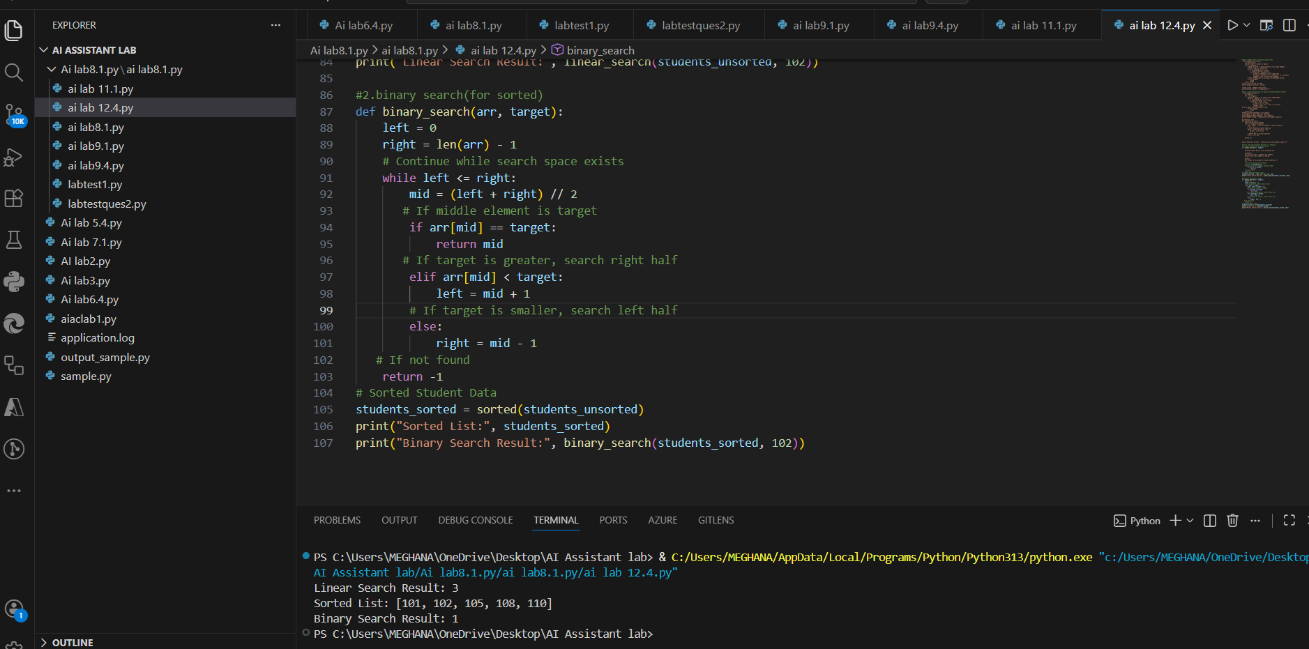
Expalnation:
When is Binary Search Applicable?
1.Data must be sorted.
2.Dataset is large.
3.Fast searching is required.
4.Frequent search operations are performed.
Time Complexity Comparison
Algorithm | Best Case | Average Case | Worst Case
Linear Search | O(1) | O(n) | O(n)
Binary Search | O(1) | O(log n) | O(log n)
Highlight performance differences between the two searches:
1.Linear Search checks every element one by one.
2.Binary Search divides the search space into half each time.
3.Binary Search is much faster for large sorted datasets.
Task 4: Choosing Between Quick Sort and Merge Sort for Data Processing

Prompt: Complete recursive Quick Sort and Merge Sort, add docstrings, and compare their performance on different dataset orders.”
1.Quick Sort Implementation:
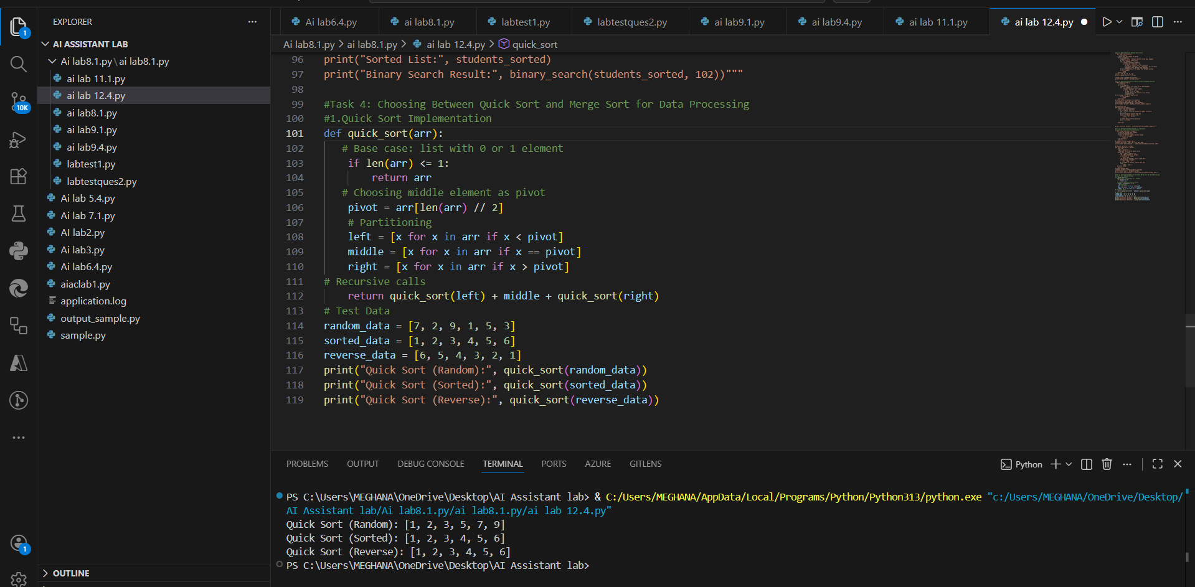
2. Merge Sort Implementation:

Expalnation:
How Recursion Works
Quick Sort Recursion
1.Picks a pivot.
2.Splits list into smaller sublists.
3.Recursively sorts left and right.
4.Combines results.
Merge Sort Recursion
1.Divides list into halves.
2.Recursively sorts each half.
3.Merges sorted halves.
Complexity Comparison
Algorithm | Best Case | Average Case | Worst Case
Quick Sort | O(n log n) | O(n log n) | O(n²)
Merge Sort | O(n log n) | O(n log n) | O(n log n)
Task 5: Optimizing a Duplicate Detection Algorithm
Prompt: Analyze duplicate detection using nested loops and optimize it using sets to improve time complexity
1.Brute-Force Duplicate Detection (O(n²)):
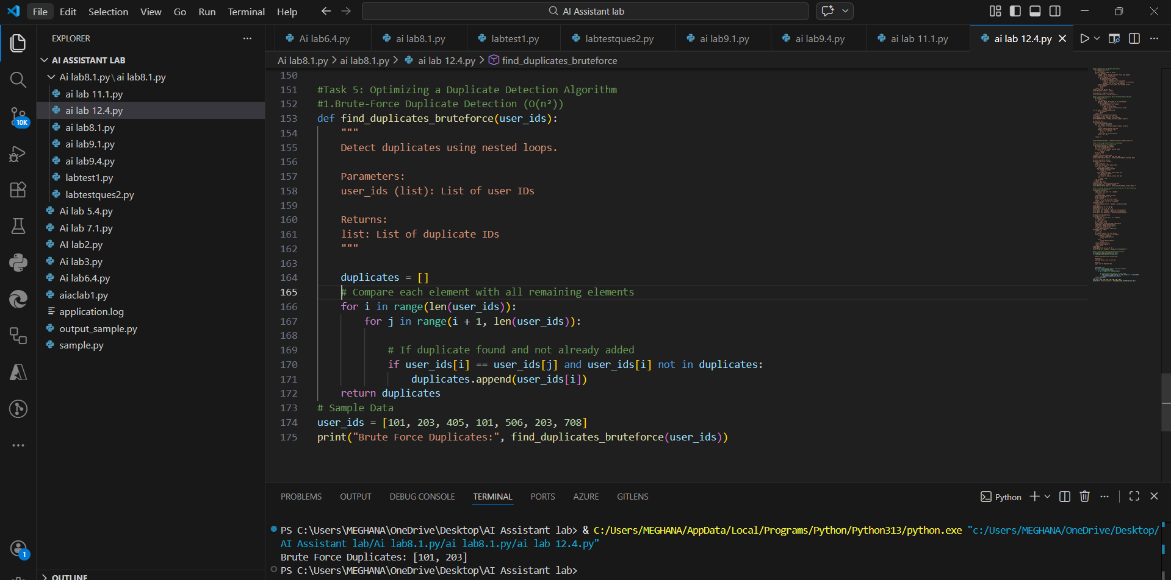
2. Optimized Duplicate Detection Using Set (O(n))


Expalnation:
1.Brute-force method is simple but inefficient.
2.Time complexity O(n²) makes it unsuitable for large datasets.
3.Using set reduces complexity to O(n).
4.Optimized method uses extra memory but is much faster.
5.Best approach for real-world data validation systems.

Time Complexity Comparison
Method | Time Complexity | Suitable for Large Data?
Brute Force | O(n²) | ❌ No
Optimized (Set) | O(n) | ✅ Yes

